Project 7 Report

Members:

Kenneth Roosever

Bradley Trowbridge

Submit the source code of the implemented program and a report that includes:

A discussion of your results with screenshots of different test cases.

Logging in and checking out a video:

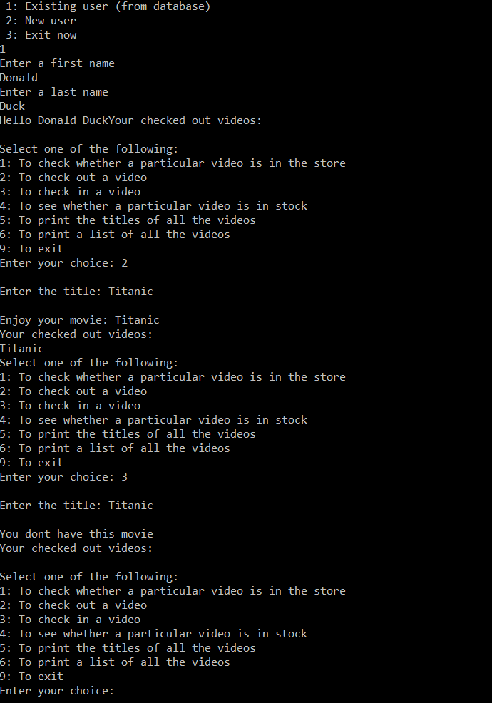

Video is out of stock because you checked it out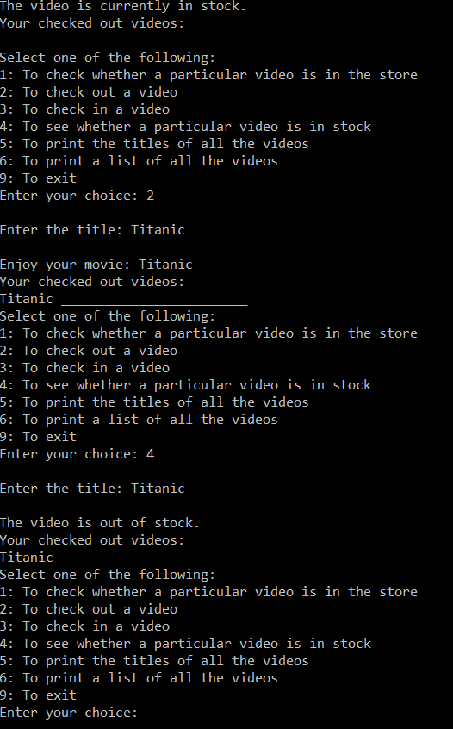

Changing to another user and trying to check out the same video that is out of stock

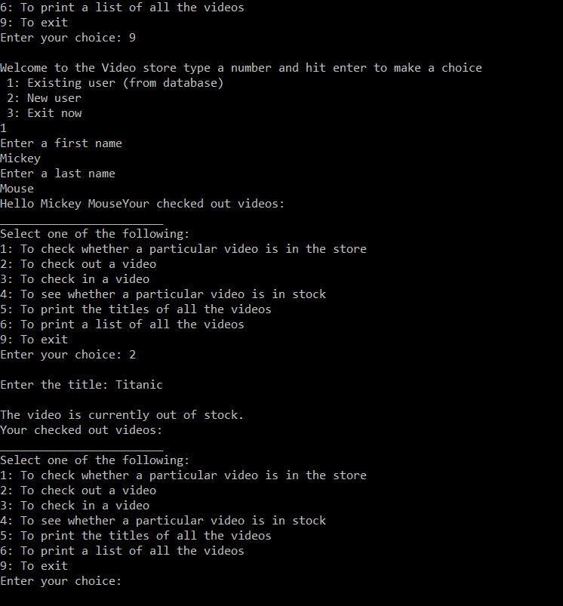

Note this is all one prompt and when exiting the store and logging in as a new customer the history remains.

• A discussion of the used data structure and the selected search algorithm as indicated above (provide justification for your selection and discussion of the complexity of the used algorithm).

We used a binary tree for the video list because it could search titles quickly;

We decided to use an unordered linked list for our movie titles and customers since the list was so small we stuck with a simple design.